Signals & Communication Systems - Lab-2
Generation of Elementary C.T. Signals: Time-Domain
Representation
Example 1: Develop Matlab code for display the unit impulse function.
sol:
t = -3:0.0001:3;
% Define unit delta function
y = ud(t,0);
figure();
%%%% uncomment the following two lines and observe the results
% plot(t,zeros(size(t)),'k','LineWidth',1); hold on; %Horizontal line as time index
% plot(zeros(size(t)),t,'k','LineWidth',1); hold on; %Vertical line as magnitude index
plot(t, y,'b','LineWidth',3); grid on;
set(gca,'fontsize',14);
xlabel('time ----->');ylabel('Amplitude ----->');
title('delta(t)');axis([-3 3 -0.1 1.2]);
Figure:

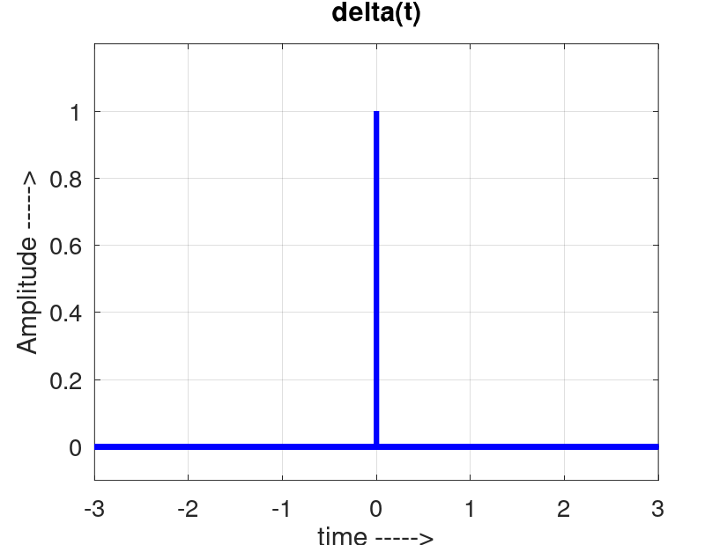

Example 2: Develop Matlab code for display the unit step function
sol:
t = -3:0.0001:3;
% Define unit step function
y = us(t,0);
figure();
%%%% uncomment the following two lines and observe the results
% plot(t,zeros(size(t)),'k','LineWidth',1); hold on; %Horizontal line as time index
% plot(zeros(size(t)),t,'k','LineWidth',1); hold on; %Vertical line as magnitude index
plot(t, y,'r','LineWidth',3); grid on;
set(gca,'fontsize',14);
xlabel('time ----->');ylabel('Amplitude ----->');
title('Unti step function');axis([-3 3 -0.1 1.2]);
Figure:
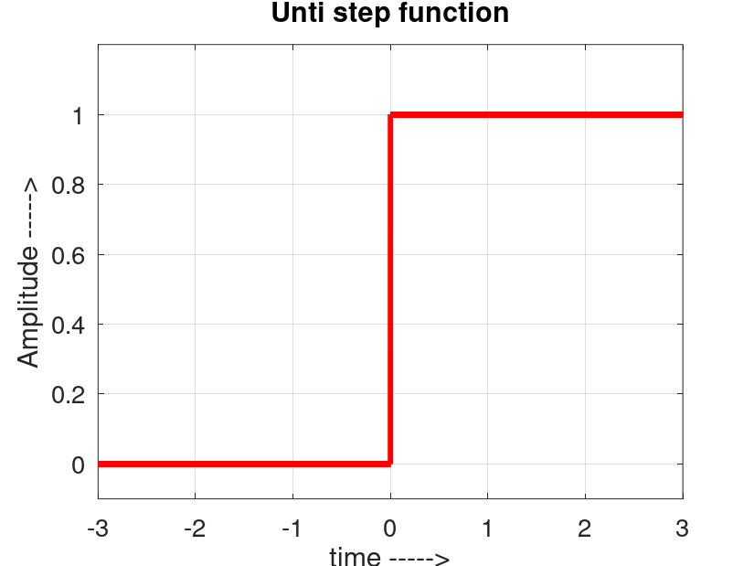
Example 3: Develop Matlab code for display the unit ramp function.
Sol:
t = -2:0.0001:6;
% Define unit ramp function
y = ur(t,0);
figure();
%%%% uncomment the following two lines and observe the results
% plot(t,zeros(size(t)),'k','LineWidth',1); hold on; %Horizontal line as time index
% plot(zeros(size(t)),t,'k','LineWidth',1); hold on; %Vertical line as magnitude index
plot(t, y,'m','LineWidth',3); grid on;
set(gca,'fontsize',14);
xlabel('time ----->');ylabel('Amplitude ----->');
title('Unti Ramp function');axis([-2 6 -0.2 6]);
Figure:
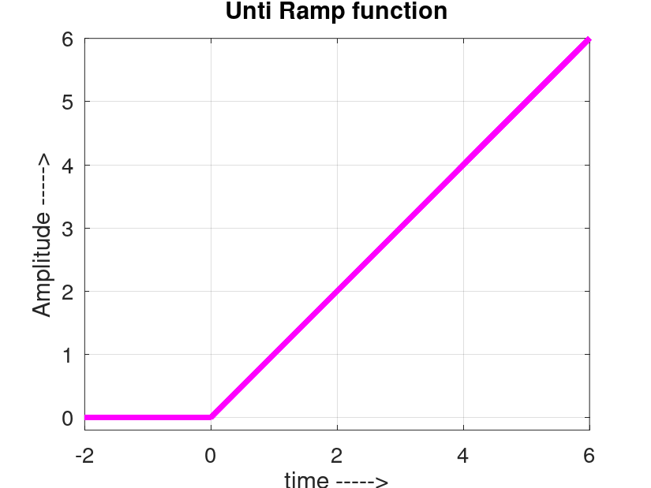
Example 4: Develop Matlab code for display a triangular pulse having unit height and unit width centered at origin
sol:
t = -2:0.001:2;
y = tripuls(t, 1); % 1 is the width of the triangle
figure;
plot(t, y, 'b', 'LineWidth', 2);
grid on;
title('Triangular Pulse');
xlabel('Time');
ylabel('Amplitude');
axis([-2 2 -0.1 1.1]);
Figure:
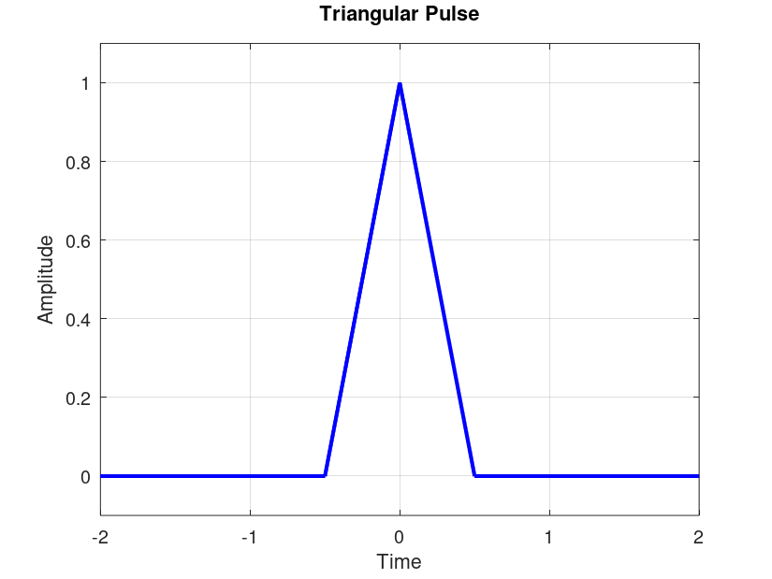
5. Example 4: Develop Matlab code for display a rectangular pulse having unit height and unit width centered at origin.
Sol:
t = -3:0.001:3;
% Manual definition of rectangular pulse of width 1 centered at 0
y = double(abs(t) <= 0.5);
figure();
% Horizontal and vertical lines
plot(t, zeros(size(t)), 'k', 'LineWidth', 1); hold on;
plot(zeros(size(t)), t, 'k', 'LineWidth', 1); hold on;
% Rectangular pulse plot
plot(t, y, 'b', 'LineWidth', 3);
set(gca, 'fontsize', 14);
title('Rectangular Pulse'); grid on;
axis([-1 1 -0.1 1.2]);
xlabel('time ----->');
ylabel('Amplitude ----->');
Figure:
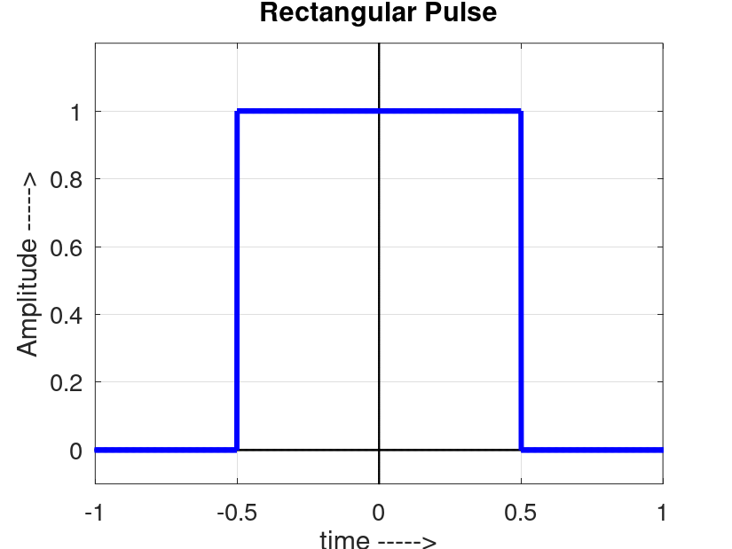
Example 6: Develop Matlab code for display a sync signal.
Sol:
t = (-pi:0.001:pi)/100;j = sqrt(-1);
A = 2; F0 = 100;
x = A*sin(2*pi*F0*t)./(2*pi*F0*t);
figure();
plot(t,x,'m','LineWidth',2.5);grid on
xlabel('time ----->');ylabel('Amplitude ----->');
title('sinc(2*pi*f*t)');set(gca,'fontsize',14);
axis([-0.03, 0.03,-0.6 2.15]);
Figure:
